My favourite dish
Ingeredients:
-Two glass of flour and one glass of milk.
-One big egg.
-Four table spoons of sugar.
- Half cube of margarine dissolved and one bar of milk chocolate and one bar of white chocolate.
-Tablespoon of baking powder.

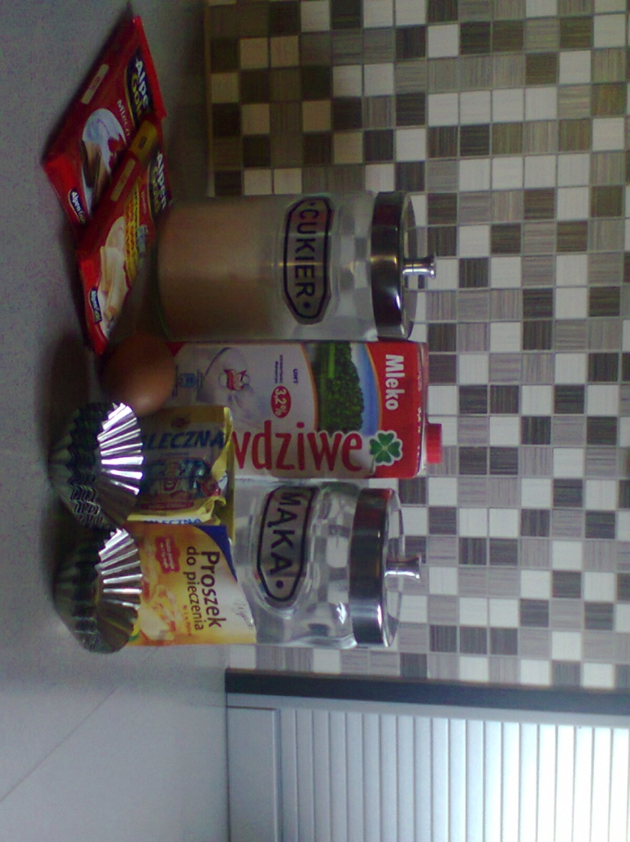

1)Mix the baking powder, sugar and flour in one bowl. 2)Mix the eggs, milk and margarine. 3)Add the ingredients from the first bowl into the liquid ingredients and add chocolate. 4)The finished mass pour into molds and bake in two hundred centigrade degrees for 15-20 minutes. Enjoy your meal.

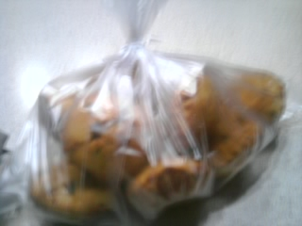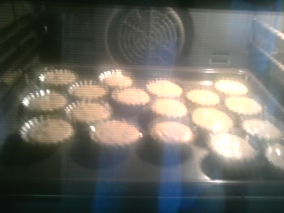

This muffins are very sweet and chocolate.
This is tasty and delicious.
Bon appetit!

