Bananas in chocolate yum!!!
components:
-bananas
-whipped cream
-cocoa
-milk
-butter
-sugar
Instruments needed:
-bowl
-pot
-knife
-spoon
-Cutting Board
1.First Pull out the things you need
2.Second put one scoop of cocoa in a pot and pour into it a large amount of milk
3. Stir with a spoon, add 2 teaspoons of sugar
4. Add a little butter and melt on heat
5. When the chocolate has melted put it away from the gas
6. Peel a banana, and cut it in half
7. Place the bananas on a plate
8. pour chocolate
9. Top it with whipped cream on the sides
10. It is ready to eat

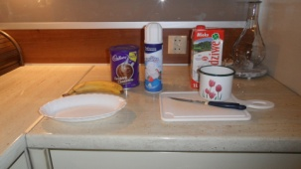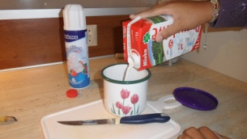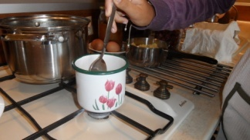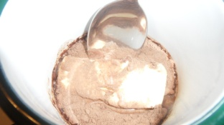

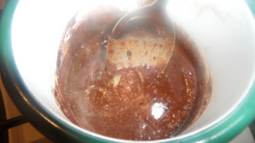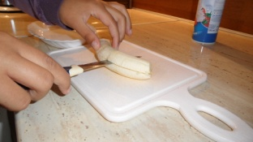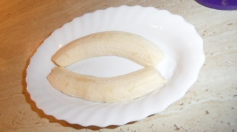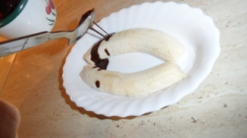

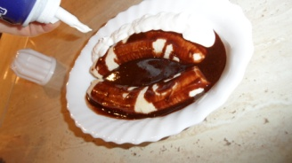

Julia Rak:)

